AI-Driven Retail Optimization: Demand Prediction, Inventory Management

  - Dilip Kumar Balu
Bellevue University
DSC 680 - T301 Applied Data Science
  - Prof. Xu Ashton
  - Oct. 4, 2026

Introduction
Retail operations constantly face the challenge of balancing inventory levels, pricing, and customer demand. Overstocking increases storage costs and the risk of spoilage, whereas understocking leads to lost sales and unsatisfied customers. Pricing decisions have a direct effect on both sales volume and profit margins. Artificial intelligence and machine learning offer structured approaches to address these challenges by leveraging historical sales, inventory, and competitor pricing data to forecast demand and support inventory planning, while providing exploratory insights into pricing–demand relationships. This white paper demonstrates how AI-driven approaches can improve operational efficiency and profitability in retail environments.
Business Problem
Traditionally, retail managers rely on intuition or past trends to make decisions about inventory and pricing. Such methods often fail to account for dynamic factors such as seasonal variations, promotions, and competitor activities. Overstocking incurs unnecessary storage costs and potential product spoilage, while understocking causes missed revenue opportunities and customer dissatisfaction. Ineffective pricing strategies can reduce competitiveness and profit margins. This project applies machine learning techniques to develop baseline demand forecasts, support inventory management decisions, and explore pricing–demand relationships using historical data.
Datasets
The analysis uses three primary datasets. The demand dataset contains historical sales, prices, promotions, seasonality indicators, and customer segments and serves as the primary source for demand forecasting. The inventory dataset includes stock levels, reorder points, lead times, and warehouse capacities to identify overstock and stockout risks, with stock levels and reorder points incorporated into the predictive model. The pricing dataset captures product prices, competitor pricing, discounts, sales volumes, return rates, and price elasticity, providing exploratory insights into pricing–demand relationships, with selected pricing features included in the baseline model. All datasets were pre-processed to remove duplicates, standardize data types, and handle missing values.
Methods
The workflow began with data cleaning, followed by exploratory data analysis, feature engineering, modelling, and evaluation. Data cleaning included removal of duplicate records, ensuring correct numeric types, and aligning the three datasets for consistency. Feature engineering introduced time-related variables such as month and weekday, a binary indicator for promotional activity, and lagged sales to capture recent trends. Exploratory data analysis examined trends, patterns, and relationships among variables. The analysis included visualization of total sales trends over time, inventory heatmaps across stores and products, scatterplots illustrating price versus sales, comparisons of sales with and without promotions, and correlation heatmaps to examine interactions among sales, pricing, and inventory features.
Sales Trends
Figure 1: Total Sales Trend Over Time
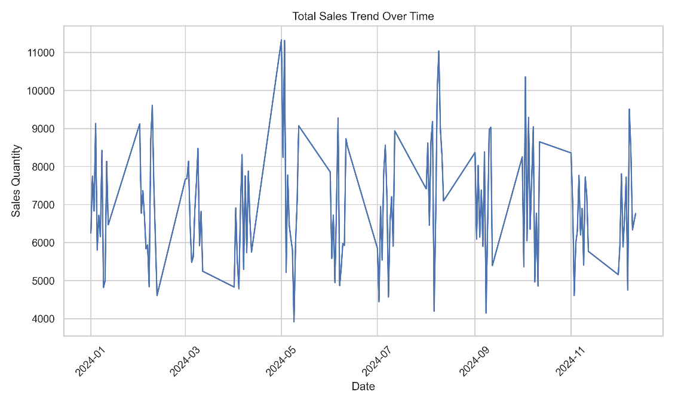
Total sales were aggregated over time to identify overall patterns and peaks corresponding to promotional events and seasonal periods (Figure 1).
Inventory Levels
Inventory distribution across stores and products was visualized using a heatmap, highlighting areas of overstocking and understocking (Figure 2).
Figure 2: Inventory Levels Across Stores
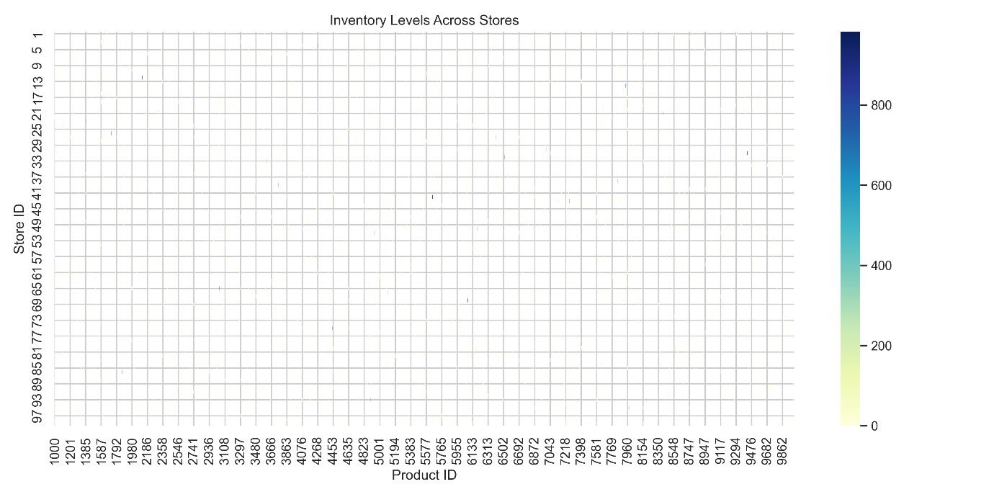
Price versus Sales
Figure 3: Price Compared to Sales Quantity
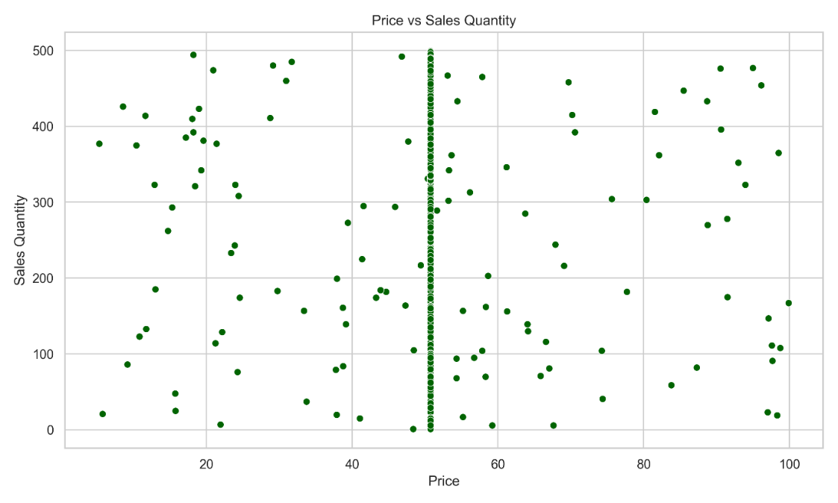
A scatterplot was used to explore the connection between product pricing and the number of sales. The findings reveal a negative relationship, as in most cases, a higher price goes together with a smaller number of sales (Figure 3).
Feature Correlations

Figure 4: Correlation Heatmap of Sales, Inventory, and Pricing Variables
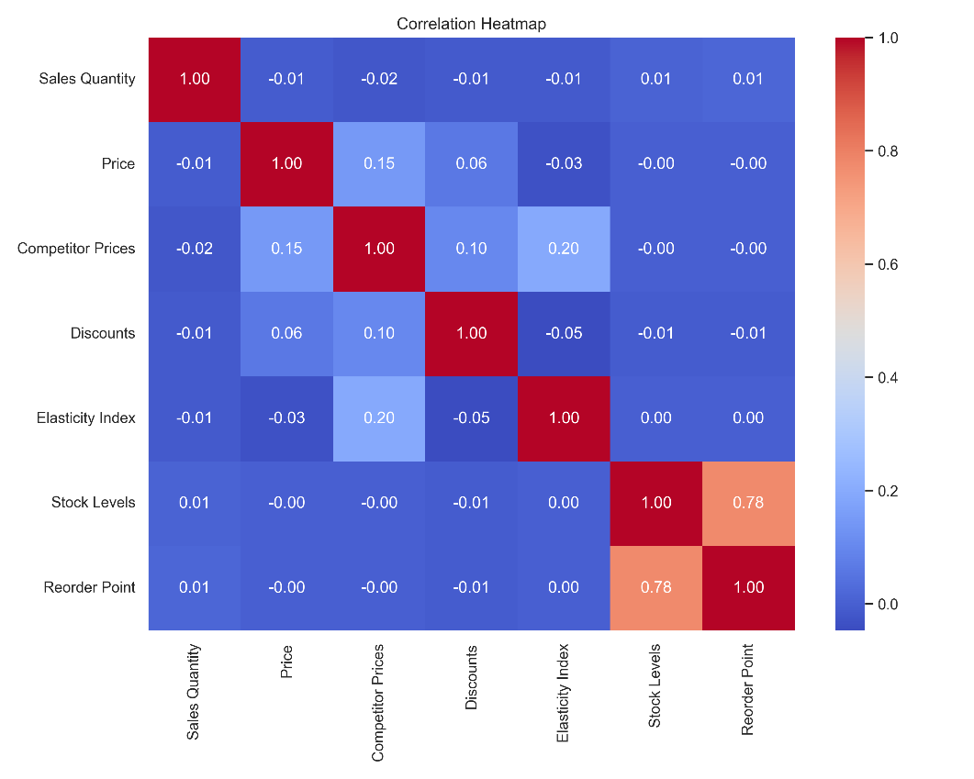
Correlation analysis was conducted to assess relationships among sales, inventory, and pricing variables. Notable relationships were observed between stock levels and sales, as well as between price and sales, highlighting key drivers of retail performance (Figure 4).
Promotional Effects
Average sales for products sold with and without promotions were compared using a bar chart. The analysis demonstrates that promotional strategies positively influence sales (Figure 5).

Figure 5: Average Sales with and without Promotions
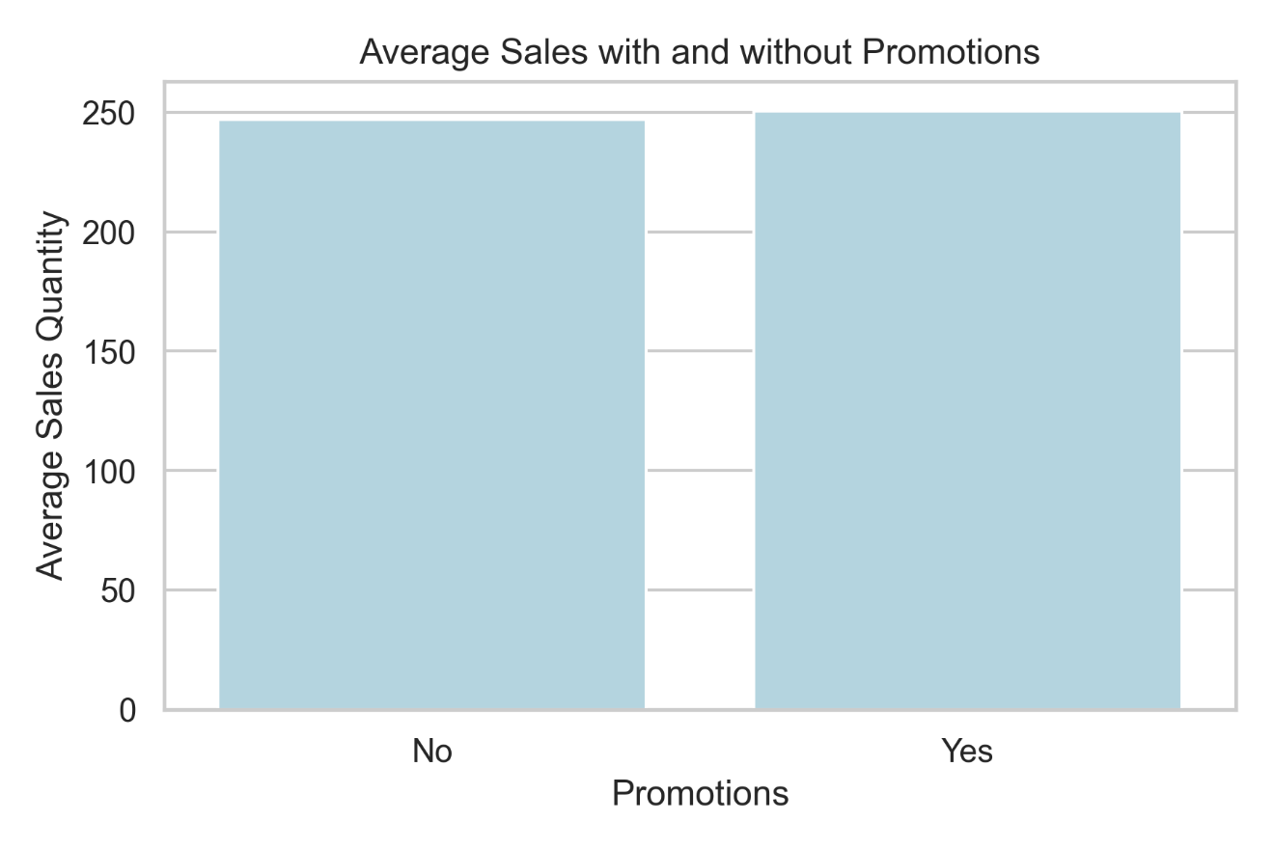
Modelling Approach
For predictive modelling, a Random Forest Regressor was used due to its ability to handle non-linear relationships and interactions among multiple features. The model incorporated pricing, inventory, promotions, and lagged sales variables, as well as derived time features. The dataset was split into training and testing sets in chronological order to maintain temporal integrity, and the model was trained on past data to predict future sales.
Model Evaluation Metrics
Model performance was assessed using mean absolute error (MAE), root mean squared error (RMSE), R² score, and mean absolute percentage error (MAPE). The Random Forest model produced an MAE of 125.55 and an RMSE of 146.30, indicating that, on average, the predicted sales quantities deviated from the actual values by approximately 126 units, with larger deviations being slightly more pronounced. The R² score was slightly negative (-0.036), suggesting that the model currently explains very little of the variation in sales and performs only marginally better than predicting the mean. The MAPE of 260.44% reflects substantial percentage errors, which are largely influenced by low or zero sales in certain product-store combinations. Given the negative R² score and high MAPE, the current model is best interpreted as an exploratory baseline, highlighting relationships among variables rather than serving as a production-ready forecasting solution
Table 1: Model Evaluation Metrics Table
MAE | 125.554351
RMSE | 146.296244
R2 Score | -0.036342
MAPE (%) | 260.443934

Figure 6: Residual Plot
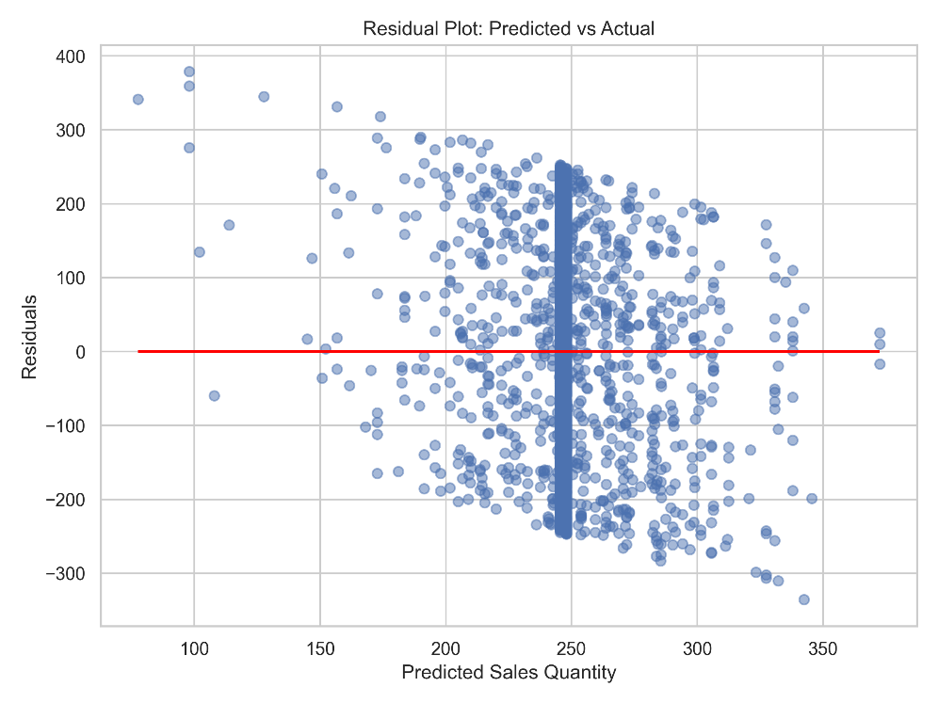
Residual plots showed no strong systematic bias, and the Predicted vs Actual line plot highlighted
that the model captures general trends but struggles with extreme values.

Figure 7: Predicted vs Actual Sales Quantity
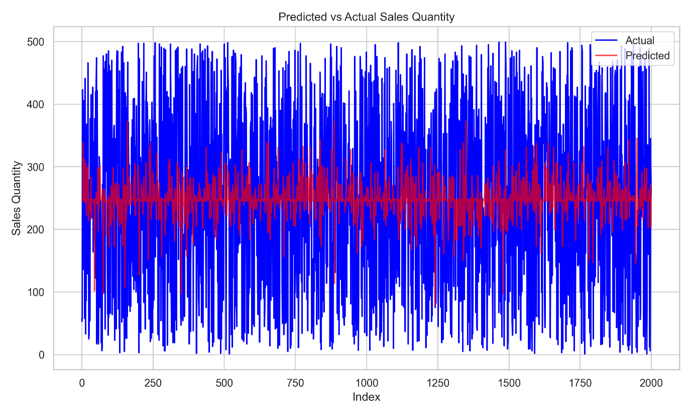
Feature importance analysis indicates that temporal factors, like Month, Weekday, are the most influential drivers of retail sales performance. Among operational variables, promotional activity and
Figures 8: Feature Importance Bar Chart
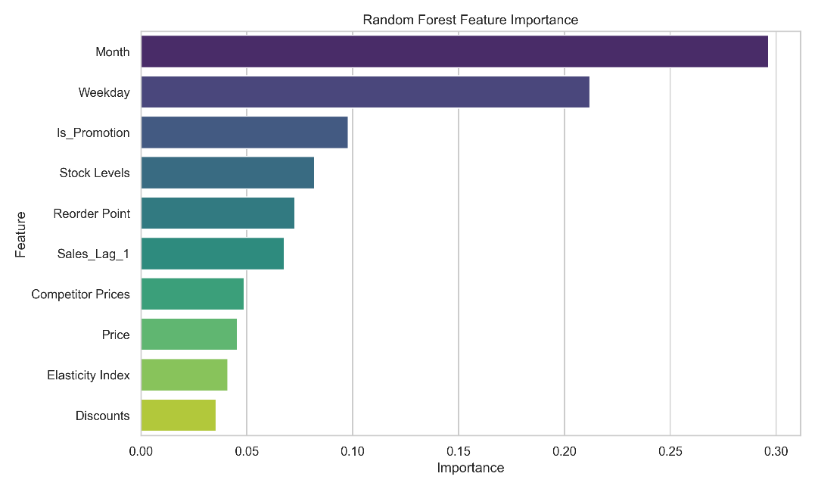

stock-related metrics (such as stock levels and reorder points) also play a meaningful role, while price, discounts, and elasticity measures exhibit comparatively lower influence in the model.
Business Insights and Recommendations
The exploratory analysis and baseline predictive modelling provide directional insights for retail operations. Exploratory pricing analysis indicates that sales volume is sensitive to price changes and competitor pricing, while promotional activities consistently lead to higher sales. Maintaining inventory levels close to established reorder points—particularly for high-demand products—helps minimize stockout risk while avoiding excessive overstock. Feature importance results further suggest that promotional activity and stock-related metrics are key drivers of sales performance, whereas pricing variables play a more limited role in the current baseline model. These findings enable managers to prioritize promotions and inventory controls when allocating resources and planning inventory strategies.
Future Work
Future enhancements include integrating the predictive model with automated inventory replenishment systems to generate reorder recommendations directly based on forecasted sales. Advanced techniques such as gradient boosting, XGBoost, or neural networks may be explored to improve forecasting accuracy further. Additional features such as weather, holidays, and localized demand patterns could be incorporated to capture more granular effects on sales.
Ethical Considerations
All customer and sales data used were anonymized to protect privacy. Model predictions and recommendations are monitored to prevent bias toward certain products, stores, or customer segments. Transparency and documentation ensure that stakeholders can understand AI-driven decisions, while the potential impacts on suppliers, employees, and customers were considered to maintain responsible practices.
Challenges
Merging multiple datasets was challenging due to differing formats and time intervals. Some influencing factors, such as holidays or weather, were only partially accounted for. Ensuring a balance between model accuracy and interpretability was critical to produce actionable insights. Pricing-related insights were interpreted cautiously to ensure compliance with regulatory and ethical guidelines.
Conclusion
This analysis demonstrates how integrating demand, inventory, and pricing data with machine learning techniques can enhance retail decision-making. Exploratory analysis revealed meaningful correlations between sales, inventory, promotions, and pricing. Predictive modelling provided a baseline demand forecasting framework and identified key drivers of sales, laying the foundation for future improvements in inventory management and more advanced pricing analysis. The results underscore the value of AI-driven retail optimization for operational efficiency and profitability.

Appendix A: Random Forest Regression Evaluation Code and Metrics

# -------------------------------
# Random Forest Regression
# -------------------------------
rf = RandomForestRegressor(n_estimators=100, random_state=42)
rf.fit(X_train, y_train)
y_pred = rf.predict(X_test)

# -------------------------------
# Model Evaluation
# -------------------------------
mae = mean_absolute_error(y_test, y_pred)
rmse = np.sqrt(mean_squared_error(y_test, y_pred))
r2 = r2_score(y_test, y_pred)
mape = np.mean(np.abs((y_test - y_pred) / y_test)) * 100 # MAPE in %

eval_table = pd.DataFrame({
'Metric': ['MAE','RMSE','R2 Score','MAPE (%)'],
'Value': [mae, rmse, r2, mape]
})
print("=== Random Forest Model Evaluation ===")
print(eval_table.to_string(index=False))

References
IAEME. (n.d.). Data-driven forecasting and inventory optimization in retail supply chains using hybrid machine learning models. https://iaeme.com/Home/article_id/IJECR_05_01_002
JungleScout. (n.d.). Monitoring competitor pricing trends: A guide for retailers. https://www.junglescout.com/resources/articles/monitoring-competitor-pricing-trends
Kaggle. (n.d.). Inventory optimization for retail: Pricing optimization dataset. https://www.kaggle.com/datasets/suvroo/inventory-optimization-for-retail
MoldStud. (n.d.). AI for optimizing demand forecasting and inventory management in retail. https://moldstud.com/articles/p-ai-for-optimizing-demand-forecasting-and-inventory-management-in-retail
NetSuite. (n.d.). Competitor-based pricing: How to price your products for maximum profit. https://www.netsuite.com/portal/resource/articles/business-strategy/competitor-based-pricing.shtml

